Disc Brake Installation Procedure :

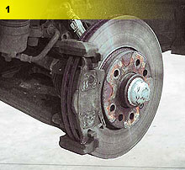 |  | Brake disc and pads have been worn down completely. Before carrying out any repairs check all the relevant axle and hydraulic components. Any defective components must be replaced immediately.
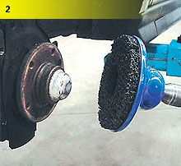 |  | Take off the old brake disc and clean the contact surface as well as the edge of the hub with a suitable tool (e.g. wire brush, emery cloth, pan brush). The calliper which is still connected to the hydraulics, must be positioned so that the brake hose is not tensioned.
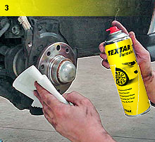 |  | Clean the derusted metallic contact surface with Textar brake cleaner. We recommend you use a special tool (measuring gauge with a stand) to check the cleaned hub for any lateral run-out.
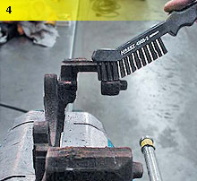 |  | Clean off any rust and residue on the calliper bracket guide shafts using a wire brush or calliper file depending on the design. Make sure that the bracket is not damaged (visual check).
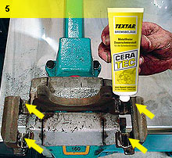 |  | Apply a non-conductive, heat-resistant and particle-free (non-metal) grease to the cleaned guide surfaces. Do not use copper paste!
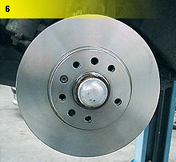 |  | Attach the mounted brake disc with the"so-called" securing bolts (often incorrectly referred to as centering bolts). We recommend that you check the new brake discs for lateral run-out on the vehicle. To do this, position a measuring gauge approx. 15 mm below the largest radius. For this purpose it is necessary to mount the brake discs and the wheel bolts (shorter bolts are also available) flush against the hub with the specified torque.
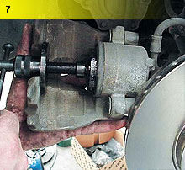 |  | The brake piston must always be moved back with the aid of special adjusting tools so as to prevent it jamming or twisting. Various types of callipers and brake systems are used. Pay attention to the individual manufacturer's specifications.
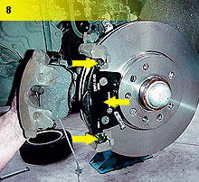 |  | Anti-squeal paste is not required on the backing plates of pads with so-called secondary measures such as damping lacquer coatings or plates. Only grease the area around the pad contact points in the guide shafts. It is important to pay attention to the torques and specifications / guidelines issued by the vehicle and system manufacturers at each stage in the repair procedure.

