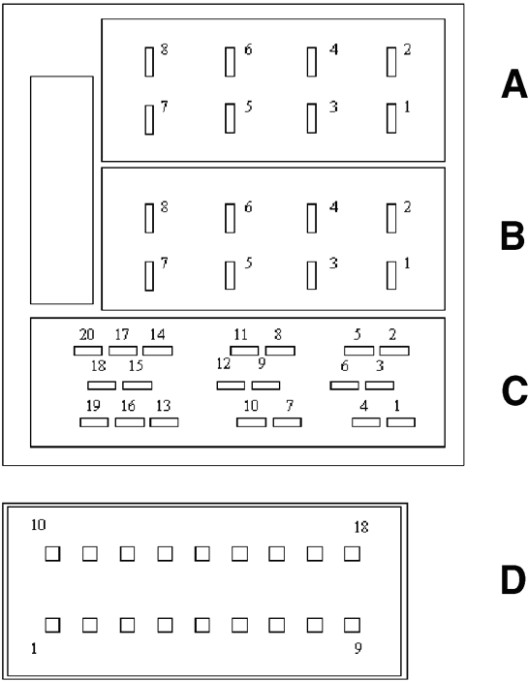 | Connector A [8 pins]
 | A1 CAN BUS (B)
 | A2 BOSE Amplifier Input
 | A3 CAN BUS (A)
 | A4 N/C (w/manual says lights) - Entry of the contact {+15} ???
 | A5 12V Switched for Aerial
 | A6 NC
 | A7 +12v Constant
 | A8 Ground [Earth]
 | Connector B Speakers [8 Pins]
 | B1 - Loudspeaker Rear Right {+}
 | B2 - Loudspeaker Rear Right {-}
 | B3 - Loudspeaker Front Right {+}
 | B4 - Loudspeaker Front Right {-}
 | B5 - Loudspeaker Front Left {+}
 | B6 - Loudspeaker Front Left {-}
 | B7 - Loudspeaker Rear Left {+}
 | B8 - Loudspeaker Rear Left {-}
 | Connector C [20 pins]
 | C1 - 5 Not Connected
 | C6 - 12V Switchable for BOSE amplifier
 | C7-9 Not connected
 | C10 Remote Control Signal A
 | C11 Remote Control Signal B
 | C12 Signal Earth
 | C13 ASCI-BUS in (for CD Changer)
 | C14 ASCI-BUS out (for CD Changer)
 | C15 12V Permanent (for CD Changer)
 | C16 12v Switchable (for CD Changer)
 | C17 ASCI-BUS Earth
 | C18 NF-Input Earth (for CD Changer)
 | C19 Input L (for CD Changer)
 | C20 Input R (for CD Changer)
 | Connector D [18 pins]
 | D1 - No Connection
 | D2 - No Connection
 | D3 - No Connection
 | D4 - No Connection
 | D5 - No Connection
 | D6 - Hook - Receiver Hang-Up Trigger [?mute?]
 | D7 - Audio Signal {Out Towards Built-In Telephone Receiver}
 | D8 - Microphone Input {From Built-In Telephone Receiver}
 | D9 - Microphone Input
 | D10 - No Connection
 | D11 - No Connection
 | D12 - Gnd [Earth]
 | D13 - No Connection
 | D14 - No Connection
 | D15 - No Connection
 | D16 - Audio Indicator - Audio Input From Built-In phone Receiver
 | D17 - Microphone Indicator - To Built-In Telephone Receiver
 | D18 - Microphone Indicator

