http://forum.alfa156.net/forum/forum_posts.asp?TID=59889
Okay so I will start my apologising that there maybe something of a lack of pictures during this thread, it somewhat hard to take pictures of a lot of peices that need them as they're often in dark and concealed spaces and my fone has no flash.
so it starts off like this:
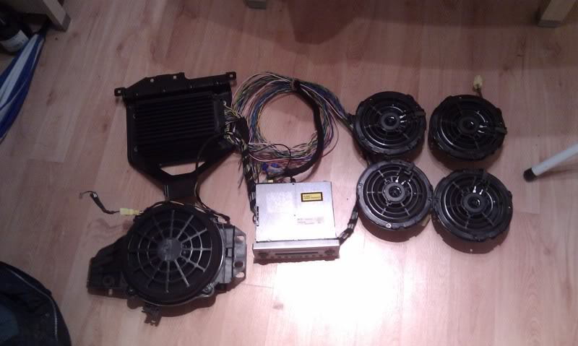
you should have, to complete the BOSE install:
1 x Blaupunkt facelift stereo - they should all be BOSE capable
4 x BOSE door speakers. They are tweeter and mid woofer combined in one unit. they are both 4 ohms each but wired in parallel making 2 ohms. (*1)
1 x BOSE sub woofer
1 x BOSE Amplifier
1 x BOSE wiring loom (*2)
2 x BOSE front door handle BOSE speaker grills (not essential)
1 x BOSE upper boot lining (not essential).
after that you are going to need some considerable patience and a set of screw drivers and allen keys, thats probably about it, oh yeh and a soldering iron and heat shrink.
right, you will note I've marked a couple of things as (*):
(*1): the speakers show to the amp as 2ohm impedance, as its a tweeter and mid wired in parallel. Resistance in parallel is calculated as R.sum = 1 div (1/R1 + 1/R2 + 1/Rn). So in this case you have R.sum = 1 div (1/4 + 1/4), which equals R.sum = 1 div 1//2 aka 1 div 0.5 which makes 2, so its 2 0hm impedance. This means amp should flow more current and make for a better sound, apparently.
(*2) the 156 is wired entirely differently to the 147 as it turns out. the 147 has a seperate harness that intersects the standard radio channel outputs just behind the dash. this then spits off to go to the amp, then comes back again and feeds the speakers, making the BOSE system totally plug and play for a 147. However, having removed the BOSE system from the donor vehicle I am sad to say this is not the case. the wiring loom for a 156 with BOSE is entirely different to that of a standard car. In the case of the 156 the 4 x speaker channels run from the amp straight to the door speakers, instead of to a plug behind the dash. this means you have to be a little creative with the wiring.
now for getting started.
First trick is to mount the amp. To do this you will need to remove the upper lining in the boot. twist off the lock caps along the trailing edge of the boot and near the light unit. there are then two push/pop pins in each corner just to the bumper side of the suspension struts and some more along the very back against the seat. take all these out and remove the lining. just pull, its very flexible. the BOSE one differs from the standard one as it has a hole for the sub in it and seems a little deeper on other side for the amp, however this isnt essential and you could cut a hole in yours for the sub, a good sharp stanley blade will do the trick.
the amp mounts on the passenger side of the car. you will see that the amp's mounting plate has a wide end and a narrow upturned end. the upturned end goes towards the rear windscreen and sits on a monting plate there. you will need to take the two bolts out the mounting plate in order to secure it when replacing the bolts. I couldnt get a picture through the glass for reflection but you can't miss it. the nuts on the back are welded to chasis so wont come off but will spin. I should add that this is made difficult by the seatbelt pretensioner charges for the rear belts being in the way at this point, making access hard, let alone taking photos. you can get the amp in place without moving the rear shelf but you cant secure it at the seat side without moving shelf.
so at this point you have to remove the rear seats, didn't bother to take photos of this point as it is outside the scope of this guide.
with the rear seats removed you will see on the inside of the car that there are several push/pop plugs that hold the shelf down at the rear seat. remove these. Should add at this point these usually break and you can buy new ones from halfords for about 2 quid a pack, as I did.
you will see under the shelf, in the boot space, that there are mounting feet held by 6 screws in total at either side, I think thats all there is. this should allow you to lift the shelf high enough, with a bit of wriggling, to get to the mounting points for the sub and amp. I never actually totally removed the shelf, just lifted it up.
whilst inside you can feed the subwoofer mount through the gap you created and mount in exactly the same way the amp does with the two bolts by windscreen turned up at an angle. again these are fiddly and i wouldnt have managed it without me in the car and my mate in the boot helping me to tighten these down. same for the seat end bolts him holding nuts in boot whilst I tightened bolts inside.
both the sub and amp are secured by 4 bolts, two each end. the sub does unbolt from the mounting frame, as does the amp. there is no point removing amp from mount but you should remove speaker from mount to save damaging it whilst being installed.
once that it done you will need the wiring loom. its at this point you can have some pictures.
I can't advise enough that you remove the wiring loom from the donor vehicle yourself. as standard the wring comes down behind the back of the passenger rear seat, across the front of the seat and down the drivers side of the car.
however, as explained the door speakers are hard wired to the amp, so the two passenger side speaker channels do run down the passenger side, however all the power, remotes and inputs for the amp run down drivers side. you will want to get as much wiring as you can out of the donor vehicle, so you will need to cut all the insulation tape off the wiring harness and rip it all out. easy done so dont be afraid. I cut mine off just by the accelerator pedal which is where it went behind the dash and I couldnt get to.
its at this point you will notice all the wiring is in pairs.
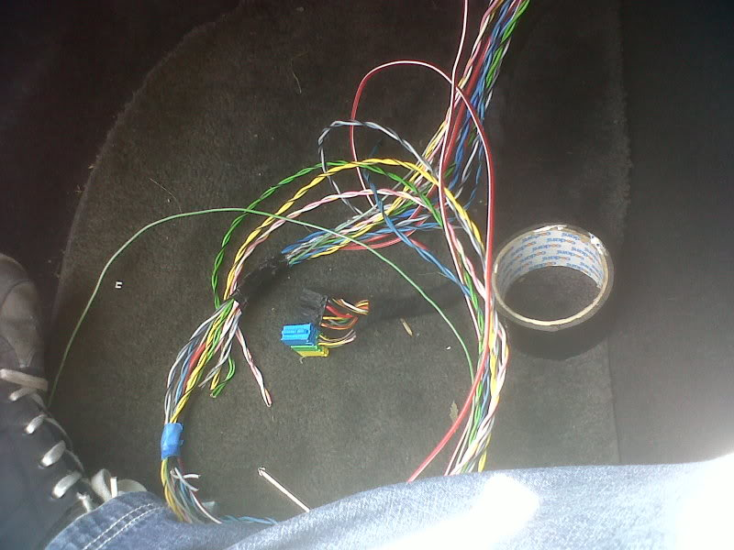
this is what I currently have in my footwell (will explain more later).
will will have the following wires:
two pairs of green wires - passenger rear channel
two pairs of grey wires - passenger side front channels
two pairs of blue wires - drivers side rear channels
a pair of yellow and a white and pink pair (feck knows) - front drivers side channels
I think they are all the right way around, however the pairings are correct even if the channels are not exactly to the right colours.
this makes it really simple to wire the amp in. you will also notice that in these pairs the colours are slightly different, so different shades of blue, green grey etc. furthermore the wires are different gauges. the wires that input the amp are slightly finer gauge (thinner). this is because being pre-amp they carry much less current. this makes the post-amp wires thicker, as they carry more amplifed current. this makes it even easier to wire the amp in.
so you will need to run these wires into the dash. to do this I recommend going through centre console. if you atempt to remove the door shut trims they WILL break. don't think you know better, they are brittle as hell, don't do it.
I run mine dow the back of the seat, across the seat base and under the carpet staight under the centre console.
Two screws hold the centre console down at the back, pull the gearlever surround and handbrake gaitor and undone the other 3 screws, wiggle it up a touch to feed the wires under.
you get this:
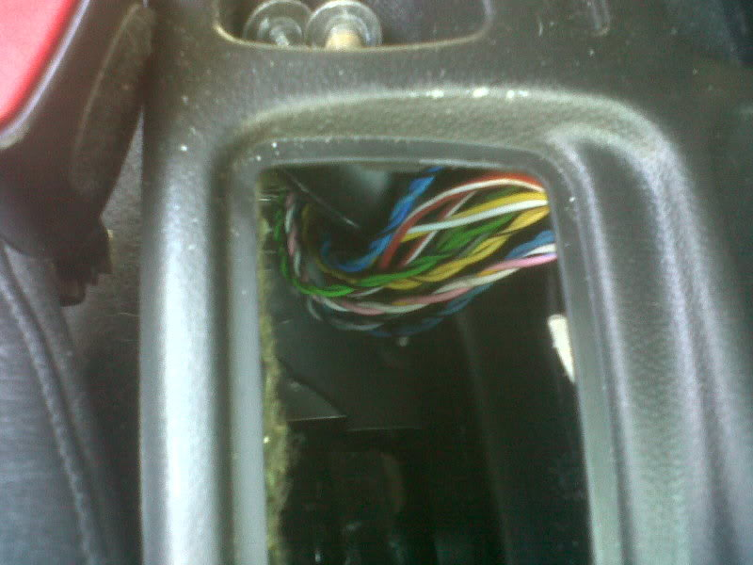
yes that is the back of the centre console. I have since tie wrapped them all together and taped the up in place.
feed them down the passenger side and feed them round the gear shift lever and poke it through the back of the dash so it comes out in the passenger footwell just above the carpet.
this is where the standard headunit wiring runs, hence why you want it there.
hooked in the handy wiring cable clips provided
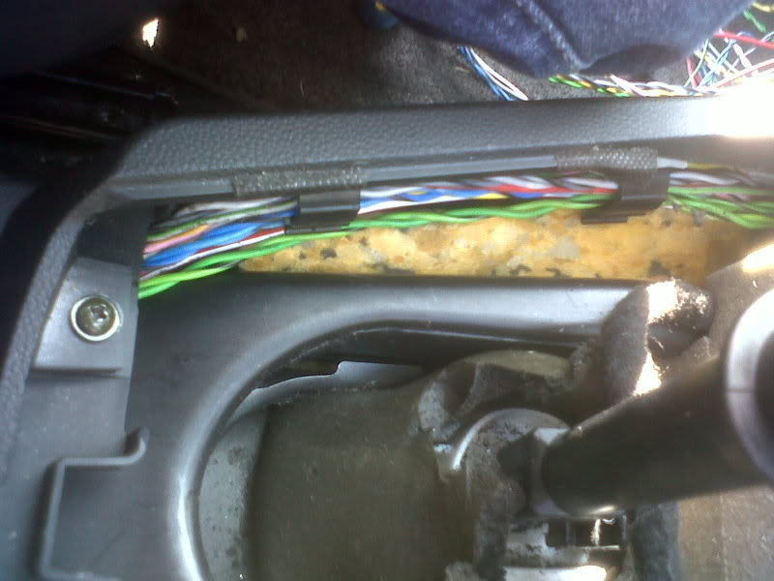
thats around the gear lever and you end up with all these wires in your footwell:
now this is where I get to be continued.
I have cut the plugs off the head unit from the donor car, so I have a male connector I will wire in for the inputs from head unit to the amp.
I have then got an ISO aftermarket stereo harness and power extender so I can plug into the standard speaker connector (that would normally go into head unit) and take power for the amp without cutting into the cars wiring.
this means I do not alter any of the cars standard wiring at all and it can all be removed later should I feel like it
but pics of that crucial stage will follow later when I get more time.
at this point I took a leaf out of my cat's (Tigger) book:

