EDC-15C Common Rail injection control unit
It is fitted in the passenger compartment on the passenger side panel. The control unit is the 'flash EPROM' type, i.e. reprogrammable from the outside without intervening on the hardware.
The injection control unit integrates the absolute pressure sensor.
PINS
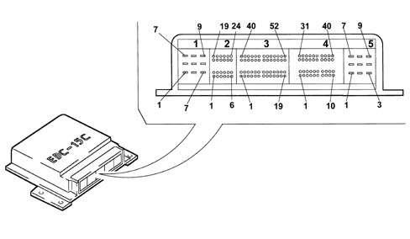

wtyk A
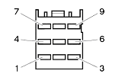
1-01, (+) Battery from the main relay (10 A)
1-02, N.C.
1-03, N.C.
1-04, (-) Battery
1-05, (-) Battery
1-06, (-) Battery
1-07, (+) Battery from the main relay
1-08, (+) Battery from the main relay
1-09, N.C.

wtyk B
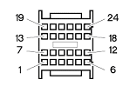
2-01, Heater plugs timer signal
2-02, Clutch pedal switch
2-03, Air conditioner engagement request
2-04, N.C.
2-05, N.C.
2-06, N.C.
2-07, N.C.
2-08, Brake pedal switch
2-09, N.C.
2-10, N.C.
2-11, N.C.
2-12, N.C.
2-13, Supply controlled by the ignition
2-14, N.C. / CRUISE SET +
2-15, N.C.
2-16, N.C. / CRUISE SET -
2-17, N.C.
2-18, N.C.
2-19, N.C.
2-20, N.C. / CRUISE RECALL
2-21, N.C. / BRAKE PEDAL SWITCH
2-22, N.C. / CRUISE OFF
2-23, Request to engage 1st fan speed
2-24, N.C.

Cruise control switch Alfa 156 FL
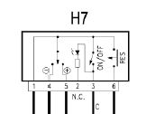

1 -> 2-22
2 -> N.C.
3 -> + Battery (Fuse 10A)
4 -> 2-16
5 -> 2-14
6 -> 2-20

wtyk C
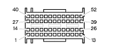
3-01, Fuel temperature sensor earth
3-02, N.C.
3-03, N.C.
3-04, N.C.
3-05, Supply for sensor 1 - accelerator pedal
3-06, N.C.
3-07, N.C.
3-08, Earth for sensor 2 - accelerator pedal
3-09, Signal for sensor 2 - accelerator pedal
3-10, Signal for sensor 1 - accelerator pedal
3-11, N.C.
3-12, N.C.
3-13, Immobilizer
3-14, N.C.
3-15, N.C.
3-16, N.C.
3-17, N.C.
3-18, N.C.
3-19, N.C.
3-20, Enablement from 4 stage pressure switch
3-21, Supply for sensor 2 - accelerator pedal
3-22, N.C.
3-23, Earth for sensor 1 - accelerator pedal
3-24, Fuel temperature sensor signal
3-25, N.C.
3-26, Vehicle speed signal
3-27, N.C.
3-28, Tester connection (line K)
3-29, N.C.
3-30, Electric fuel pump supply
3-31, N.C.
3-32, N.C.
3-33, N.C.
3-34, N.C.
3-35, N.C.
3-36, N.C.
3-37, Supply for E.G.R. modulator
3-38, Operation of heater plugs timer (+)
3-39, N.C.
3-40, Rpm sensor signal
3-41, N.C.
3-42, N.C.
3-43, Heater plugs warning light
3-44, CRUISE LED (+)
3-45, Request to engage 2nd fan speed
3-46, Main relay
3-47, N.C.
3-48, Engine Check warning light
3-49, Water temperature warning light
3-50, E.G.R. actuator
3-51, Operation of heater plugs timer (-)
3-52, Electric fuel pump
wtyk D
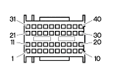
4-01, Flow meter supply
4-02, Rpm sensor earth
4-03, Rpm sensor signal
4-04, Flow meter earth
4-05, N.C.
4-06, Supercharging pressure sensor signal
4-07, Excess pressure sensor earth
4-08, Excess pressure sensor supply
4-09, N.C.
4-10, N.C.
4-11, Flow meter supply
4-12, Rpm sensor supply
4-13, Fuel pressure sensor supply (5 V)
4-14, Flow meter signal
4-15, Quadrinary on
4-16, N.C.
4-17, Rpm sensor screening
4-18, N.C.
4-19, N.C.
4-20, N.C.
4-21, Fuel pressure sensor
4-22, N.C.
4-23, Air temperature sensor signal
4-24, Fuel pressure sensor signal
4-25, N.C.
4-26, Rpm sensor signal
4-27, Engine temperature sensor earth
4-28, N.C.
4-29, N.C.
4-30, N.C.
4-31, Pressure regulator
4-32, Air conditioning system relay
4-33, N.C.
4-34, Fuel pressure sensor earth
4-35, N.C.
4-36, Engine temperature sensor signal
4-37, N.C.
4-38, N.C.
4-39, N.C.
4-40, N.C.
wtyk E
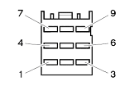
5-01, N.C. (1.9 JTD)
5-01, Supply for injector for cylinders 2 and 5 (2.4 JTD)
5-02, Supply for injector for cylinders 1 and 4 (1.9 JTD)
5-02, N.C. (2.4 JTD)
5-03, Operating signal for injector for cyl. 4 (1.9 JTD)
5-03, Operating signal for injector for cyl. 5 (2.4 JTD)
5-04, Supply for injector for cylinders 2 and 3 (1.9 JTD)
5-04, Supply for injector for cylinders 1, 3 and 4 (2.4 JTD)
5-05, Operating signal for injector for cylinder 3 (1.9 JTD)
5-05, Operating signal for injector for cylinder 1 (2.4 JTD)
5-06, N.C.
5-06, N.C.
5-07, Operating signal for injector for cyl. 2 (1.9 JTD)
5-07, Operating signal for injector for cyl. 4 (2.4 JTD)
5-08, N.C. (1.9 JTD)
5-08, Operating signal for injector for cyl. 3 (2.4 JTD)
5-09, Operating signal for injector for cyl. 1 (1.9 JTD)
5-09, Operating signal for injector for cyl. 2 (2.4 JTD)

